COMP3900\_6390 Assignment 2: Diprotodon Exhibit

Semester 2, 2016

**Group number: 15 and list of student names and UIDs**

Jiahao Wang u5833429

Sumit Shinde u5923560

Tiange Wang u5715141

Edward Kopka u5351945

**Table of Contents**

[**Part 1** 2](#_Toc460615447)

[**The on-line system idea** 2](#_Toc460615448)

[**1.1Describe the Exhibit** 2](#_Toc460615449)

[**1.3 Comparison with 3 other existing online systems** 5](#_Toc460615450)

[**Part 2** 8](#_Toc460615451)

[**Use Case Scenario** 8](#_Toc460615452)

[**2.1 Scenario Situation** 8](#_Toc460615453)

[**2.2 Persona** 9](#_Toc460615454)

[**2.3 Use Case Description** 9](#_Toc460615455)

[**Part 3** 9](#_Toc460615456)

[**Early-stage prototype** 9](#_Toc460615457)

[**Part 4** 11](#_Toc460615458)

[**Design Decisions** 11](#_Toc460615459)

[**References** 12](#_Toc460615460)

# **Part 1**

# **The on-line system idea**

## **Describe the Exhibit**

The exhibit is an enormous skeleton of an extinct marsupial. It is known as the Diprotodon. Visitors can view the exhibit from two angles. From the side, the skeleton is observed through a slightly transparent image, see fig 1. The image is what the Diprotodon might have looked like when it was alive. The front side can also be viewed by walking around the skeleton, see fig 2. This side includes some panels with information for the visitors. The information provided is about the Diprotodon, the environment the Australian desert used to be when the Diprotodon lived, as well as some information on how the bones were uncovered. This information is provided on panels and a small sort of book is attached to the panel which visitors can flick through, see fig 3.

## **The idea of the on-line interactive system**

The interactive website will have one main picture of the Diprotodon seen in the exhibit. The user will be able to change the view of the skeleton to be from either the front or the side. This is done using a button at the bottom right for the side view and bottom left for front view. The name of the exhibit is at the top of the page with a one line description beneath it. On the right side are four tabs which provide the user with more information if it is desired. Audio information is provided for those who prefer to listen. A language select button is also provided to accommodate for users from different cultures. A bar at the bottom of the page allows the user to fade between the skeleton and the image. See fig 4 for pencil concept of the web page.

The national museum of Australia presented the skeleton with a slightly transparent image overlaid on the side view. We saw this as a neat way to show the skeleton as well as the artist image. The transition bar is an extension of that idea which would only work online. When the user moves the bar it increases/decreases the opacity of the image. On the left the user will see only the bones, on the right it will be entirely the living image.

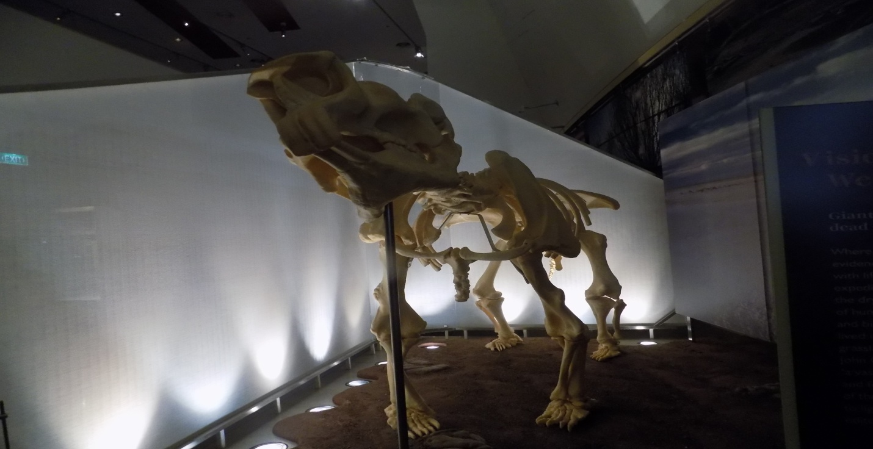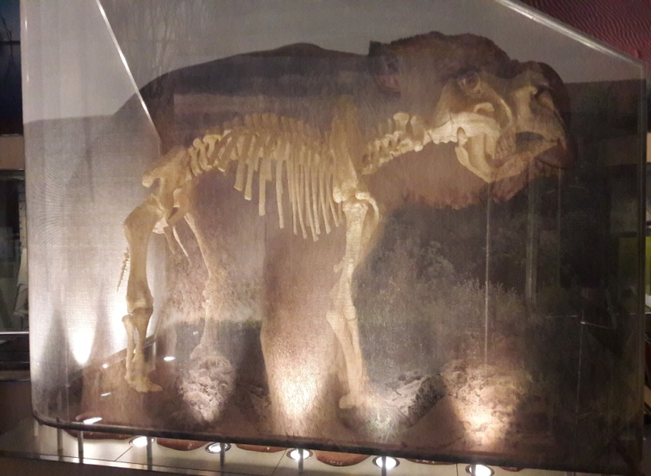

Figure 1 : Diprotodon exhibit side view

Figure 2: Diprotodon exhibit front view

Four tabs are provided on the right side of the page which provides additional information, in the same way the panels did at the exhibit. The tabs are designed based on the information originally provided. The first tab is for basic information about the Diprotodon and serves as an introduction. The second tab includes historical information of what the Australian desert would have been like when Diprotodon lived. The fourth tab provides information on the archeological dig of Diprotodon. The second tab contains access to videos of Diprotodon and animations of how it may have moved. One of the questions we had while observing the exhibit was the curiosity of how it moved around. This tab allows the user to satisfy that curiosity. Each tab contains symbols and when hovered over will extend to show a one-word description. When clicked on the tab will expand and display the information. The information may be distributed on multiple pages which are accessed by arrow keys at the bottom.

The audio control will be situated at the left corner of the page, denoted as ‘volume-off-indicator_318-76502.png.jpg’ and once user click on it, it will change its avatar to’sound.png’ and enable audio which will be an audio description of the exhibit. Depending on language that user chosen from language list, this audio feature will play description audio in that particular language and by default it will be English. Example as if the user chooses Chinese from language list then audio will be in Chinese.

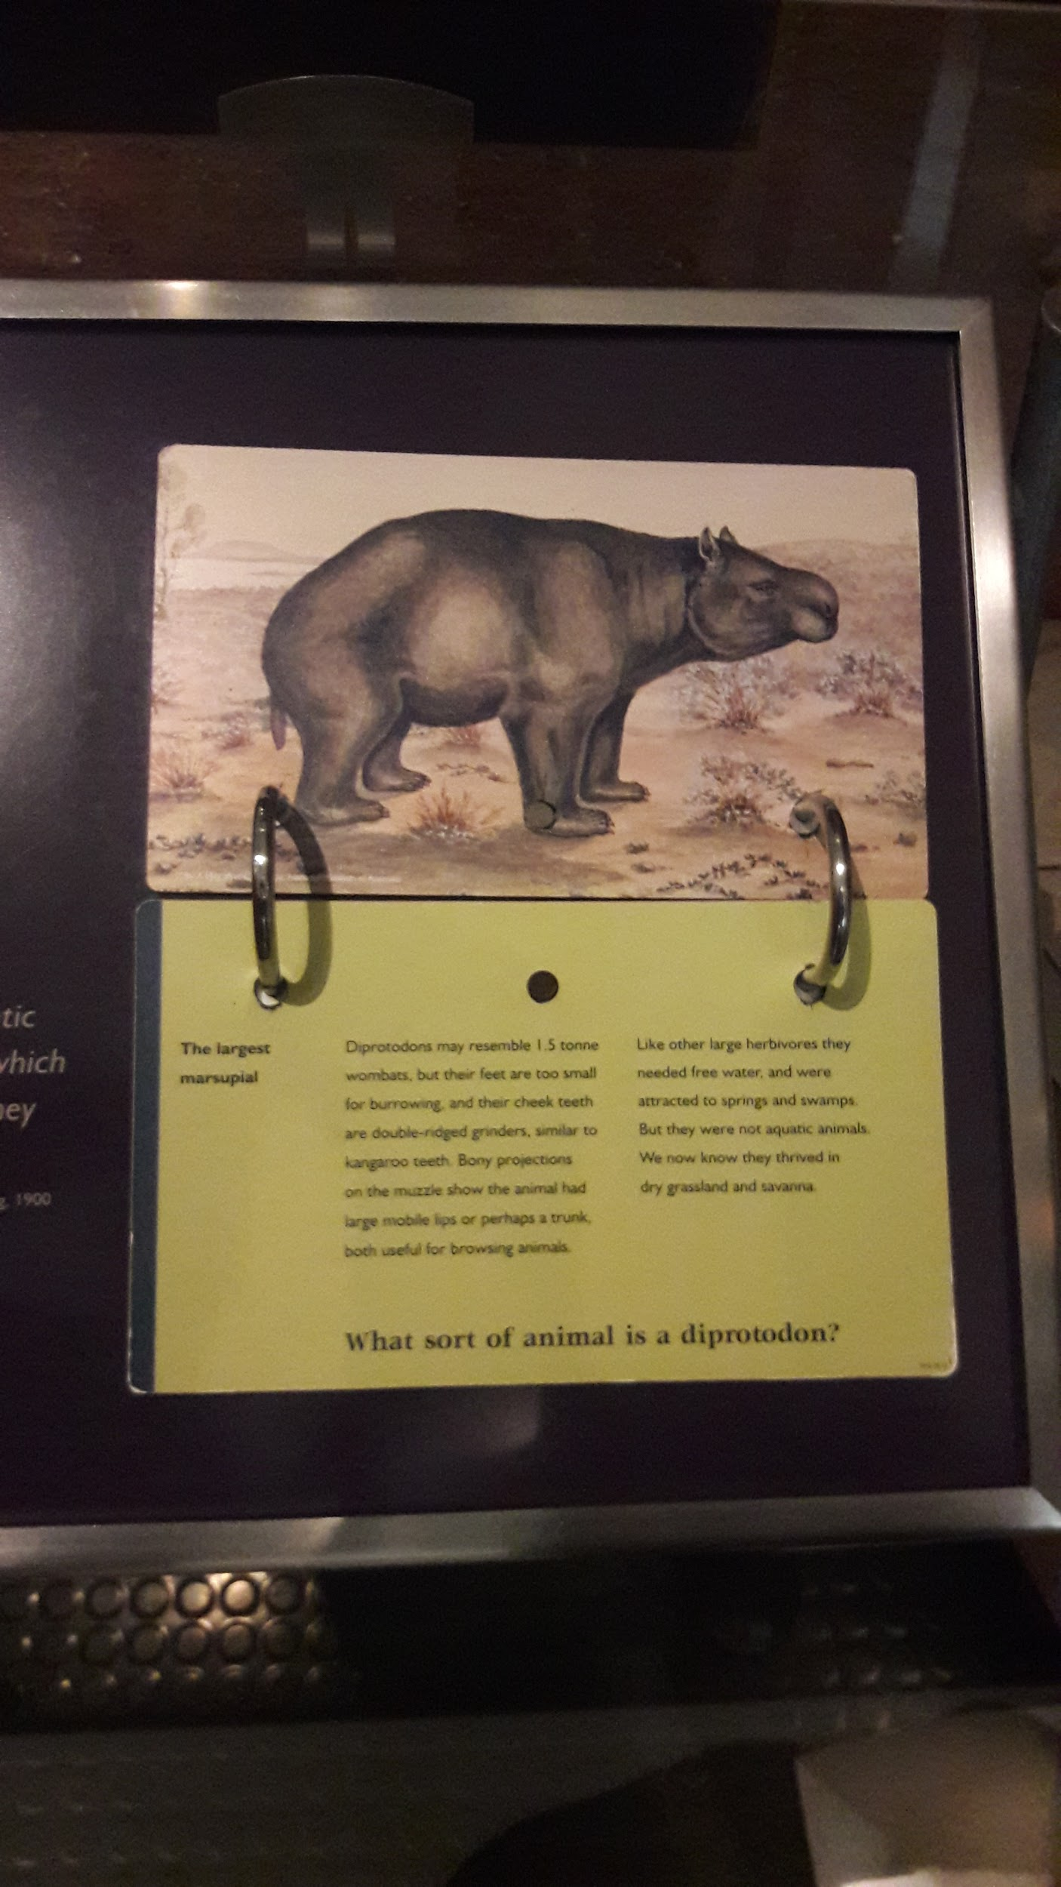

Figure 3: Information book provided at Diprotodon exhibit

## **1.3 Comparison with 3 other existing online systems**

**1.3.1 American museum of natural history**

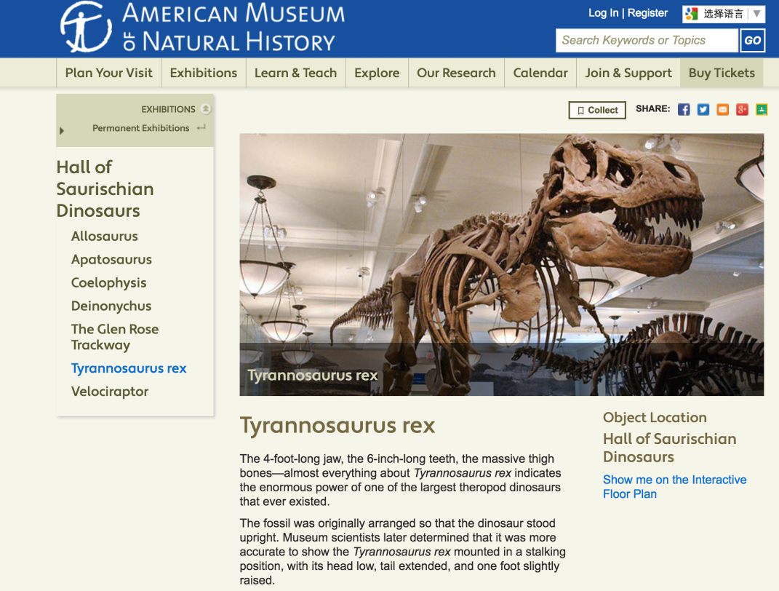

Figure 4: Page of the Tyrannosaurus rex exhibit.

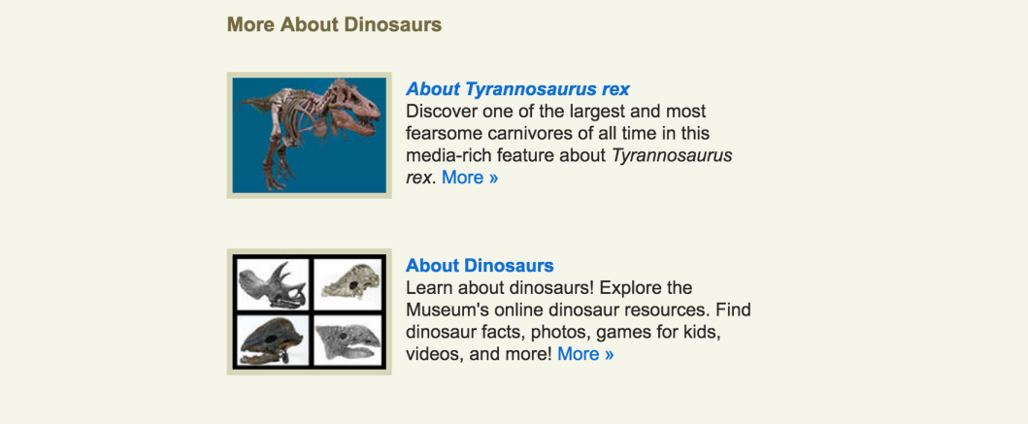

Figure 5: Links provided for more information.

The American museum of natural history uses the traditional method and classification to illustrate what is showing now in the museum. Moreover, in the bottom of every exhibit, there is some related information for it, which is convenient for visitors to gather more knowledge. However, if readers are interested in the appearance of the dinosaurs, they have to return back to the original website because the introduction and the picture are not on the same page.

By contrast, in the bottom of our design is a transition bar with the front/side view button for displaying the two side 2D model of the exhibit (Diprotodon). Since we took the problem of combination of the words and pictures into consideration, there is a translucent function frame with 4 tabs which represents information, history, discovery and video respectively. When visitors need to browse the picture rather than the words, they can easily click the tab and access more information and videos provided on right side of the image.

**1.3.2 Museu de les Ciències Naturals de Barcelona in Google Arts & Culture**

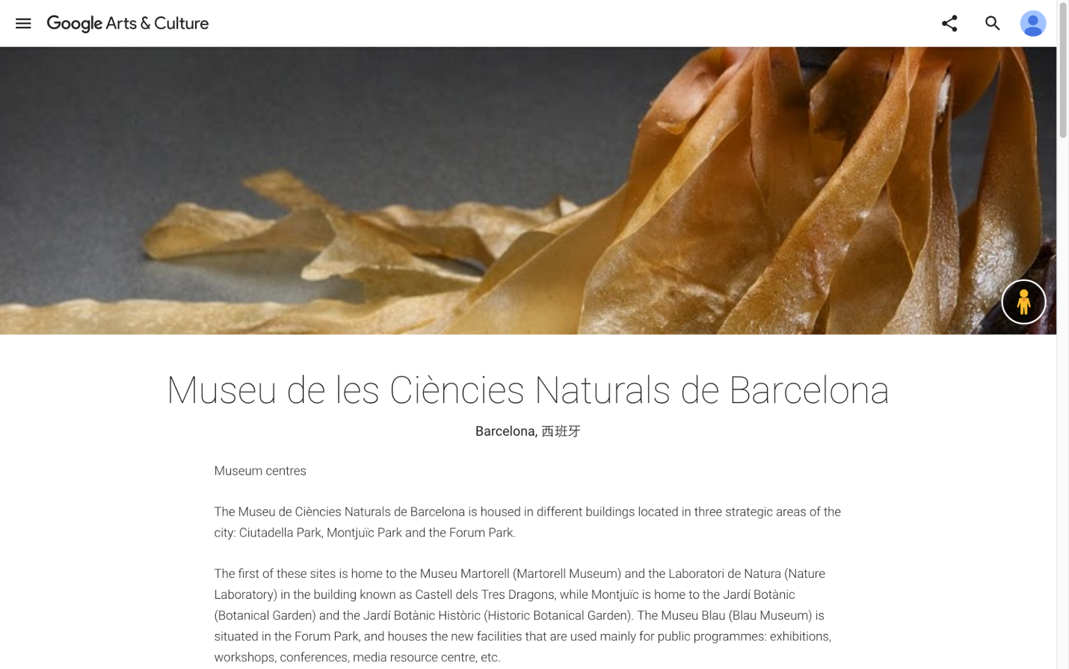

Figure 6: Web page of Museu de les Ciències Naturals de Barcelona.

Google Arts & Culture website contains plenty of well-known museums in the world. Museu de les Ciències Naturals de Barcelona is one of them with the vivid color of the background. Google Arts & Culture simplified the complicated buttons and frameworks of a common official museum website and provides visitors with the information, pictures of exhibits, and the specific address on the map, opening hours which is indeed useful for visitors.

The only shortage is a lack of multilingual system. As a visitor, I cannot read and understand what the introduction says in Spanish. Hence, we have considered this problem and add the foreign language options in the top of the design for foreign people to understand.

1.3.3 Museum für Naturkunde

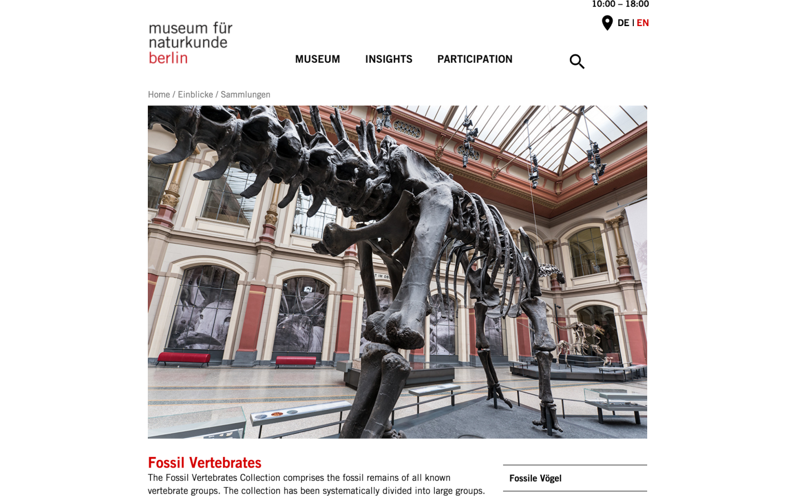

Figure 7: Website of Museum für Naturkunde.

The big dinosaur skeleton in the middle of the website of Museum für Naturkunde in Berlin is a real surprise and catches our eyes. The style of the design is concise and clear. Meanwhile, the designer also considers the foreign language options, although the website only can translate to English or back to Germany. Moreover, the opening hours notice on the top right corner and primary classification in the middle are striking for visitors to obtain what they need.

Our design follows this concise style. However, ‘concise’ does not mean discarding something. We discussed and considered what visitors really need online and ‘convenience’ is our target. Besides the combination of words and pictures, we also consider the audio function for the blind and elderly people, and design a sound button near the name of the exhibit.

# **Part 2**

## **Use Case Scenario**

## **2.1 Scenario Situation**

A student (Ted) is studying extinct Australian animals. He lives in Adelaide and wants to use various museums around Australia. He decides to begin with the National Museum of Australia and soon finds the exhibit about the Diprotodon.

## **2.2 Persona**

Ted is young, about 20-22. He is fairly tech savvy and frequently uses all the latest applications and tools. He is visually inclined and likes seeing things in person. His mental model is to both learn about extinct species but also wants to know what they might have looked like.

## **2.3 Use Case Description**

Ted observed the Diprotodon Exhibit and opened the display for it. He saw the Diprotodon from the side and can see the bones beneath the flesh. He began exploring the page by clicking the audio mute button. An audio voice recording started playing and he listened to the introductory information about the Diprotodon. He listened to some of the audio information and then pressed on the audio button again which muted it. He then experimented with the transition bar at the bottom. He moved the bar left and right and noticed how the opacity of the Diprotodon image changed to reveal the fossilized skeleton beneath. He set the slider fully to the left and only the bones were displayed. He then used the scroll wheel over the image to attempt to zoom in. The system responded by zooming the image toward where the mouse is located on the image just as Ted expected. Ted used click and drag motions to move the zoomed in the image around until he focused on the skull. Ted then tried the front view by clicking on the button. The image immediately “rotated” to show the front of the Diprotodon but fully zoomed out. Ted again played with the slider bar overlaying the image onto the bones. Ted, having moused over the right side panel buttons, clicked on the one that says “videos”. A video player filled the screen and began playing a documentary clip about the Diprotodon showing the animal moving and walking around. Ted enjoyed the video and after watching he read through some of the additional information using options in the menu before leaving the site.

# **Part 3**

## **Early-stage prototype**

Link of the prototype: <https://drive.google.com/open?id=0B2zUeUKh7bSARkJ4Q1JiNXVMb1U>

Or see the attached PDF for the screen mock-up with annotations.

At real exhibit location, there are two ways to look at it, one is from the side angle and other is from the front angle. Side angle is covered with the semi-transparent poster of Diprotodon through which we can see its skeleton. This view quickly gives us idea about Diprotodon’s body shape. To replicate this idea in online representation we are using ‘Transition Bar’. This bar allows users to change the opacity of image so that they can view skeleton and shape of Diprotodon and realize relation between them. To represent two side views we provided a button on the screen which is labeled with the name of view on another side, hence it enables users to quickly understand that there is another view and they can switch to that view by clicking that button. Users can switch many times between both views. Real exhibit consist of information book which gives more idea about Diprotodon to the reader (see figure 3). We are providing distinguished tabs which are labeled with general icons to realize what's inside it. Such as icon ’i27.jpg’ for general information of Diprotodon, icon ‘history_logo.png‘ for history information, icon ‘youtube-play-button_318-41694.jpg’ for video clip and icon ‘shovel logo.png ‘for discovery information of Diprotodon species. As on real exhibit visitor look through information book, here just clicking on buttons user can get all the information given in the book, in fact we can add more images and links to other documents in this information. While thinking about visitors with disability, at real exhibit it is enabled by museum tour guide or audio guide device, on online representation we are enabling each button including audio mute-play icon with popup text so that once screen cursor reaches on the icon the relevant text shows up and the screen reader software can read it. For visitors with hearing disability the option of on screen text and information navigation buttons will be helpful to read the specific text to gain knowledge about Diprotodon.

# **Part 4**

# **Design Decisions**

Museum provides a audio guide to visitors, it is best option to know about different exhibits without the help of the human guide. Also, it is a good option for visitors who are having vision disability so that they can gain information about the exhibit by listening introductory audio. In our design, this audio option has shown inactive to users, which is also the default setting not to startle the visitors so that if they want they can enable sound and listen through speakers. It also provides audio in different languages so that users from different cultures can make use of it. The mute button situated in the left corner is the simple audio mute button which we see most of the time on our phone, television, iPad, iPod. Hence user who can see this button can realize its meaning and enable it for audio. This button also enabled with pointer pop up text, that is if cursor comes near to this button it will show text related to the button so that user who does not understand its meaning can read through the text and perform the action. This also improves screen readability for screen reading software. This way we provide discoverability and connect it with real life experience (i.e. use of phone’s on-screen buttons).

Having different language options allows the site to be accessible to those who perhaps don’t know English very well. This supports users from multiple cultures; allowing them to interact with the system in the language they are most comfortable with. For the user who comes from the other exhibits or the front page of the museum, it will keep the language selection in the previous page. But for people access this site directly from URL or Google, the default language will be English as this is the most likely language to be used. If the user wants to change languages they can only choose from the provided options in a drop down list.

The interactive method used for viewing the Diprotodon was designed to replicate the experience felt viewing the exhibit at the museum. We decided to only show the online exhibit from two views as that were the only ways to view the real exhibit. The buttons to change the view are mapped on the side such that, it is the direction you would physically need to move to change the view. So if viewing the side view you would need to move right to view the front view and so the button is placed on the bottom right side. The inverse is true for the front view. The button is placed at the bottom so that it would not get in the way of the image or menu bars. To replicate the ability to walk closer toward the exhibit in reality a zooming type function is provided. Zooming is done using the scroll wheel and is another example of mapping the interface to the physical world. Note that for the zoom to work, the mouse must be over the Diprotodon image. This prevents slips from happening if the user accidentally moves the scroll wheel while trying to click a button or navigate the menus, when their attention isn’t on the image. The zooming feature is assumed knowledge in the head as it follows a common convention and is fairly discoverable. However, the buttons to change view have a text to indicate what the button does. Even it will respond same while performing the pinching action on laptop’s touchpad.

The real exhibit shows the relation between bones and physical shape of Diprotodon, it is to show that when they found the bones they researched and concluded Diprotodon’s life existence to the world. Visitors see bones through semi-transparent picture of Diprotodon hence in our design we providing users to change the opacity of image and knowing about the skeleton of Diprotodon and its shape. Rather than providing two - three different images , the option of transition bar is fairly easy and interactive for users which create realization for user understanding. We keep it below the image so that once users watch it , they can see the transit bar and try to use it. This transit bar is simple like volume control bar on our phone so that users can move the slider and check its effect on the image.

The menu bar was added as a way to provide the text information that in the physical exhibit was provided on panels. The menu bar is small and out of the way such that it doesn’t take away from the experience of seeing the Diprotodon. For this reason, symbols were used for each option to keep the menu as small as possible. The symbols were designed to follow conventions as much as possible, such as using an ‘I’ letter for information, or the playback symbol for videos. However, to allow the user to discover what the symbols mean a one-word description pops up when the user mouses over the symbol. This makes the menu discoverable and quick to navigate. There are four options in the menu to represent the four different areas of information that needed to be provided. 3 are the different types of information provided on the real exhibit. A fourth though, the videos, was added as it provides the ability to see the Diprotodon in action, something that could not be done in reality.

# **References**

American museum of natural history [Online] Available at:

<http://www.amnh.org/exhibitions/permanent-exhibitions/fossil-halls/hall-of-saurischian-dinosaurs/tyrannosaurus-rex> [Accessed 30 Aug 2016].

Google Arts & Culture - Museu de les Ciències Naturals de Barcelona [Online] Available at:

[https://www.google.com/culturalinstitute/beta/partner/museu-de-les-ci%C3%A8ncies-naturals-de-barcelona](https://www.google.com/culturalinstitute/beta/partner/museu-de-les-ciències-naturals-de-barcelona) [Accessed 30 Aug 2016].

Museum für Naturkunde [Online] Available at:

<https://www.naturkundemuseum.berlin/en/insights/collections/fossil-vertebrates> [Accessed 24 Aug 2016].

National Museum Australia - Animals [Online] Available at: <http://www.nma.gov.au/kspace/teachers/mungo/learning/animals> [Accessed 27 Aug 2016].